**SQL QUERIES**

1. **Calculate the average champion score and the average runner-up score and assign a rank to each row based on the year, ordered in ascending order.**

[SELECT](http://localhost/phpmyadmin/url.php?url=https://dev.mysql.com/doc/refman/8.0/en/select.html) Year,

Host,

Final_Champion,

Champion_score,

Runnerup_score,

  Final_Runnerup,

Num_of_teams,

Matches,

Total_attendance,

[AVG](http://localhost/phpmyadmin/url.php?url=https://dev.mysql.com/doc/refman/8.0/en/aggregate-functions.html%23function_avg)(Champion_score) OVER () AS Average_Champion_score, [AVG](http://localhost/phpmyadmin/url.php?url=https://dev.mysql.com/doc/refman/8.0/en/aggregate-functions.html%23function_avg)(Runnerup_score)

OVER () AS Average_Runnerup_score, ROW_NUMBER()

OVER (ORDER BY Year) AS Rank

FROM Fifa;

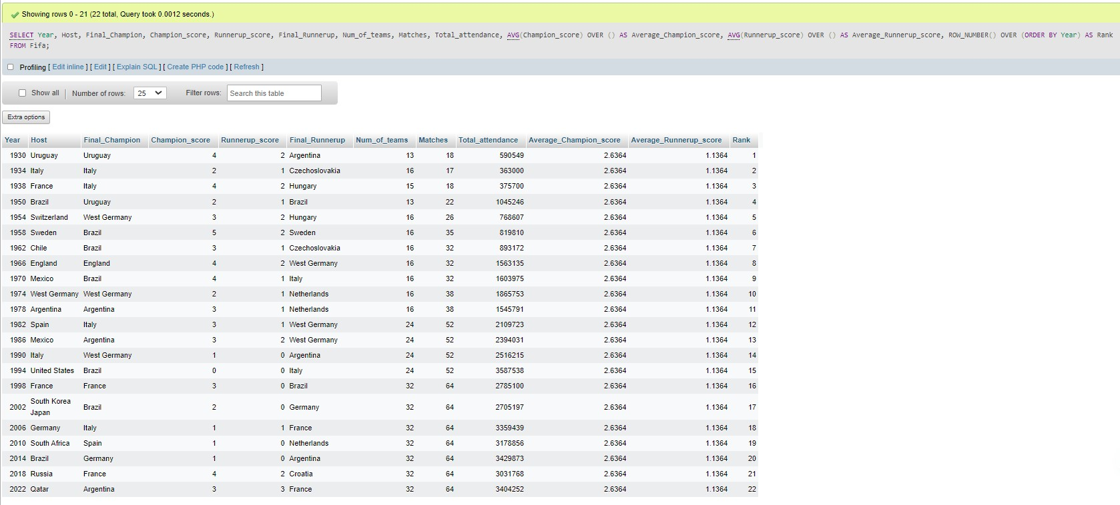

1. **Query to retrieve all matches between the champion and the runner-up in each World Cup**

[SELECT](http://localhost/phpmyadmin/url.php?url=https://dev.mysql.com/doc/refman/8.0/en/select.html) f1.Year,

f1.Final_Champion,

f1.Champion_score,

f1.Runnerup_score,

f1.Final_Runnerup

FROM Fifa f1 JOIN Fifa f2 ON f1.Year = f2.Year

WHERE f1.Final_Champion = f2.Final_Champion

[AND](http://localhost/phpmyadmin/url.php?url=https://dev.mysql.com/doc/refman/8.0/en/logical-operators.html%23operator_and) f1.Final_Runnerup = f2.Final_Runnerup

[AND](http://localhost/phpmyadmin/url.php?url=https://dev.mysql.com/doc/refman/8.0/en/logical-operators.html%23operator_and) f1.Champion_score > f1.Runnerup_score;

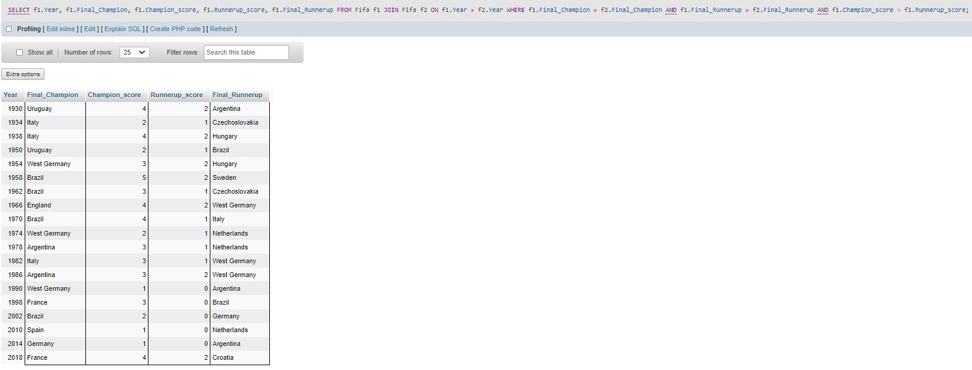

1. **Query to find all hosts whose names contain exactly five characters**

[SELECT](http://localhost/phpmyadmin/url.php?url=https://dev.mysql.com/doc/refman/8.0/en/select.html) *

FROM Fifa

WHERE Host [LIKE](http://localhost/phpmyadmin/url.php?url=https://dev.mysql.com/doc/refman/8.0/en/string-comparison-functions.html%23operator_like) '_____';

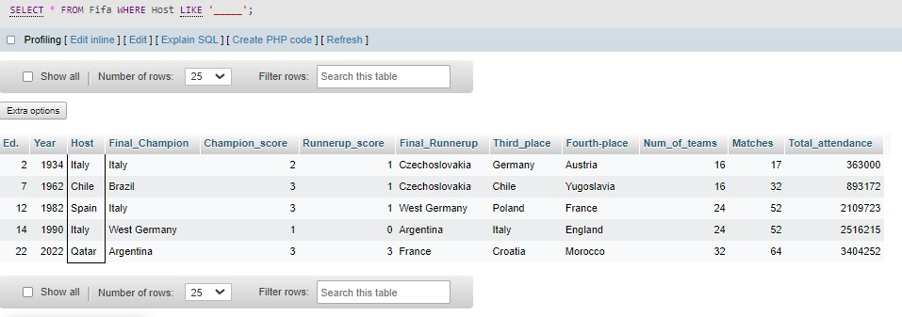

1. **Query to find all champions whose names end with "y"**

[SELECT](http://localhost/phpmyadmin/url.php?url=https://dev.mysql.com/doc/refman/8.0/en/select.html) *

FROM Fifa

WHERE Final_Champion [LIKE](http://localhost/phpmyadmin/url.php?url=https://dev.mysql.com/doc/refman/8.0/en/string-comparison-functions.html%23operator_like) '%y';

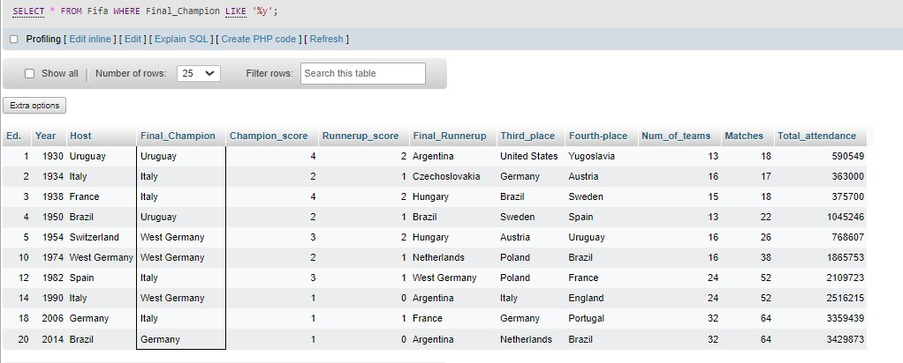

1. **Query to retrieve matches played between the years 2010 and 2022**

[SELECT](http://localhost/phpmyadmin/url.php?url=https://dev.mysql.com/doc/refman/8.0/en/select.html) *

FROM Fifa

WHERE Year BETWEEN 2010 [AND](http://localhost/phpmyadmin/url.php?url=https://dev.mysql.com/doc/refman/8.0/en/logical-operators.html%23operator_and) 2022;

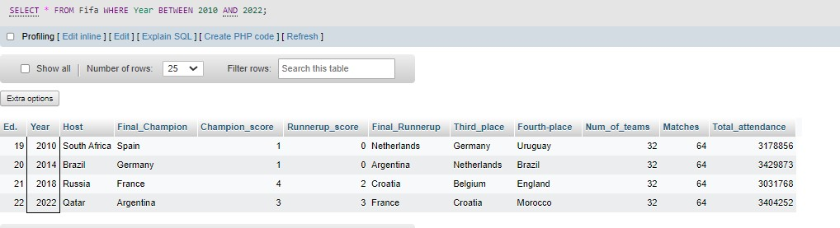

1. **Query to retrieve the host countries that have not won any FIFA World Cup**

[SELECT](http://localhost/phpmyadmin/url.php?url=https://dev.mysql.com/doc/refman/8.0/en/select.html) Host

FROM Fifa WHERE Host [NOT](http://localhost/phpmyadmin/url.php?url=https://dev.mysql.com/doc/refman/8.0/en/logical-operators.html%23operator_not) [IN](http://localhost/phpmyadmin/url.php?url=https://dev.mysql.com/doc/refman/8.0/en/comparison-operators.html%23function_in)

( [SELECT](http://localhost/phpmyadmin/url.php?url=https://dev.mysql.com/doc/refman/8.0/en/select.html) DISTINCT Final_Champion

FROM Fifa );

